Step 3: Crude Mapping each of the D. melanogaster coding exons to your D. ananassae contig

Prerequisites
- you are familiar with the Blast tool for DNA analysis
- you are familiar with the UCSC genome browser,
- You have chosen your contig and the gene or isoform from that contig
- You have the FSATA file from that contig downloaded on your computer (The FASTA File will be given to you by your GTA; note: you do not have to open that file, when you need it just browse for it and use it as a file)

Resources
- Your contig: ___6___________
- Gene name (and isoform if applicable): _______
- GEP UCSC Genome Browser: http://gander.wustl.edu
- Fly Base: http://flybase.org
- Gene Record Finder (http://gep.wustl.edu) Projects Annotation Resources
- NCBI BLAST (https://blast.ncbi.nlm.nih.gov/Blast.cgi) tBLASTn (or Blastx) select the checkbox: 

Instructions
You are here:

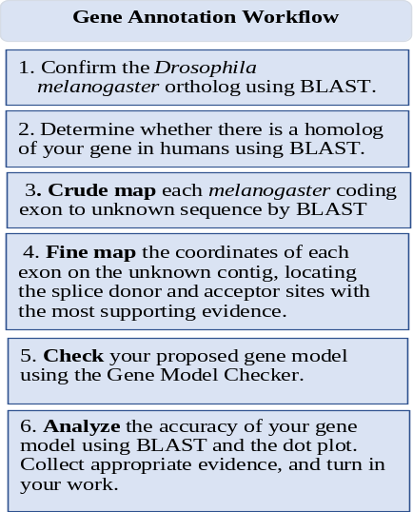
- Use the Gene Record Finder (http://gep.wustl.edu/ -> Projects/Annotation Resources) to obtain the amino acid sequences of all the D. melanogaster coding exons found in your particular gene isoform. Include a screen shot of the “Polypeptide Details” in the Gene Record Finder report in your annotation report.
- Download and save the fasta sequence of your contig onto your computer from Canvas.
- Obtain the amino acid sequence of the first exon by clicking on its row in the Gene Record Finder. Align this melanogaster coding exon sequence to the contig sequence using BLAST searches. Paste a screen shot of the alignment in your report, being sure to indicate the reading frame, and whether it is a full-length alignment. In addition to the BLAST screenshot, keep track of the details of your crude mapping on the table, starting on the next page. If your gene isoform has fewer exons than the 17 shown in the table, just leave the rest blank.

- If the alignment is not full length, change the BLAST algorithm parameters to perform a less “stringent” BLAST search, as detailed in the video tutorial.
- If changing the BLAST algorithm parameters still does not give a full-length alignment, estimate the nucleotide position of the end of the exon, assuming that exon length is conserved between Drosophila species.
- Repeat part b for each protein coding exon in your gene isoform.

Questions:
- Genome Browser screen shot: Include a screen shot of your chosen gene from the contig in the genome browser showing BlastX alignment to the D. melanogaster gene and the putative exons.
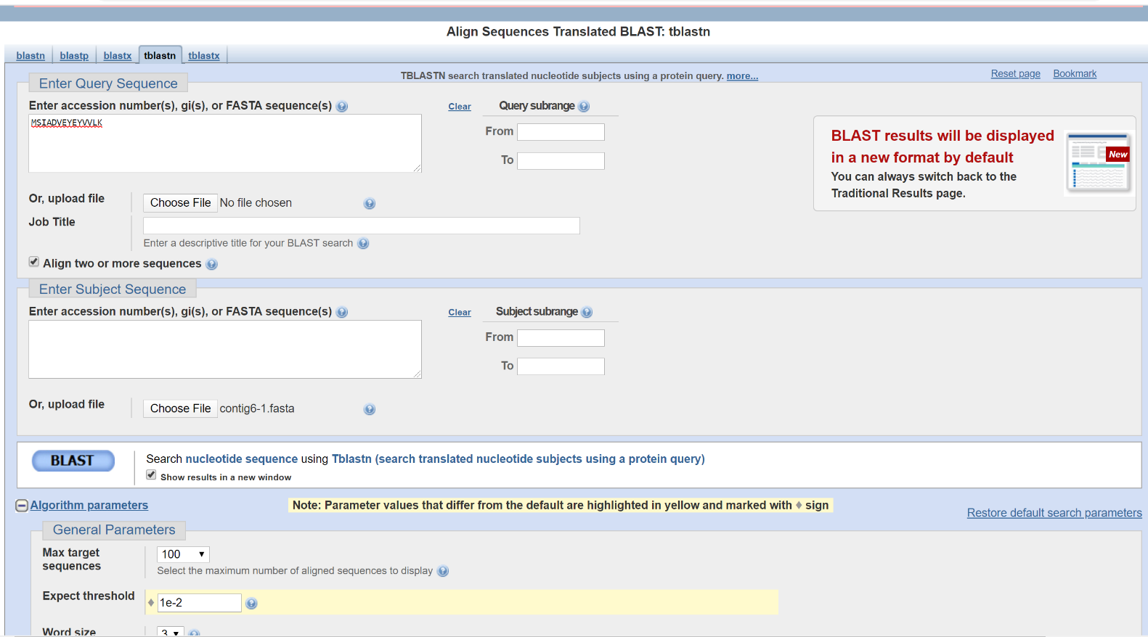

- Include a screen shot of the “Polypeptide Details” in the Gene Record Finder report in your annotation report. (the exons from the D.melanogaster ortholog)
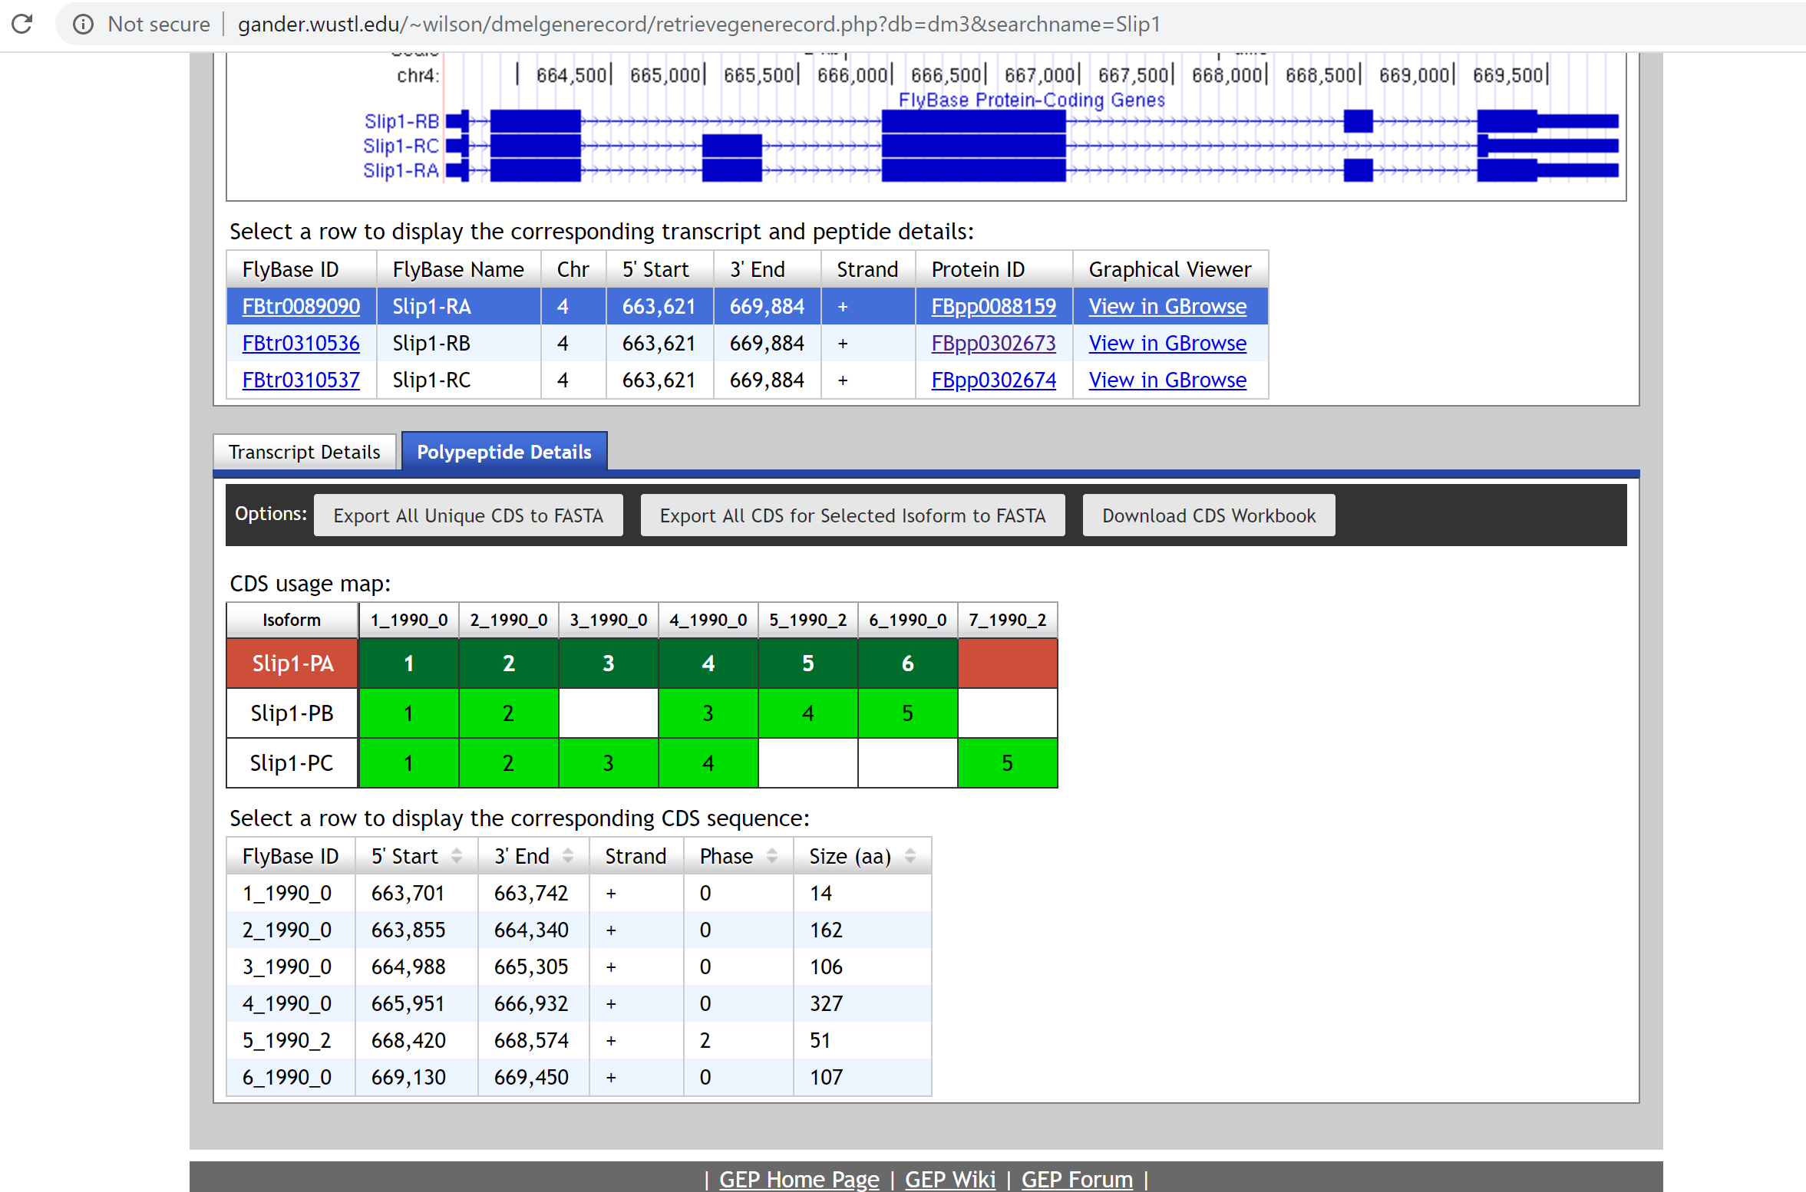

- Include the screenshot of each tBLASTn alignment for each one of your exons
Transcript SLIP1-PA - has 6 exons
Query is polypeptide sequence from exons ; Subject is Contig6 sequence.
Exon1 polypeptide
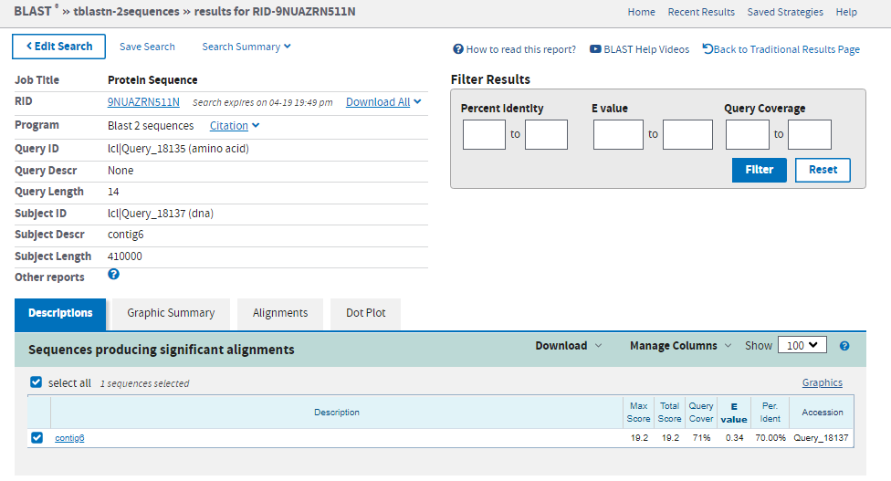
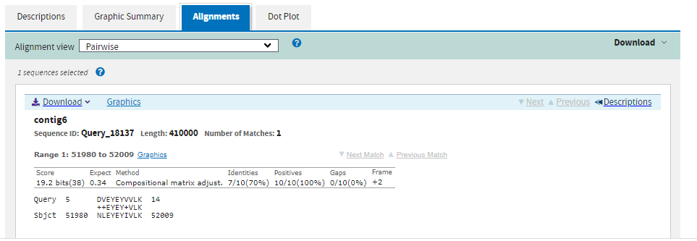

Exon 2 polypeptide
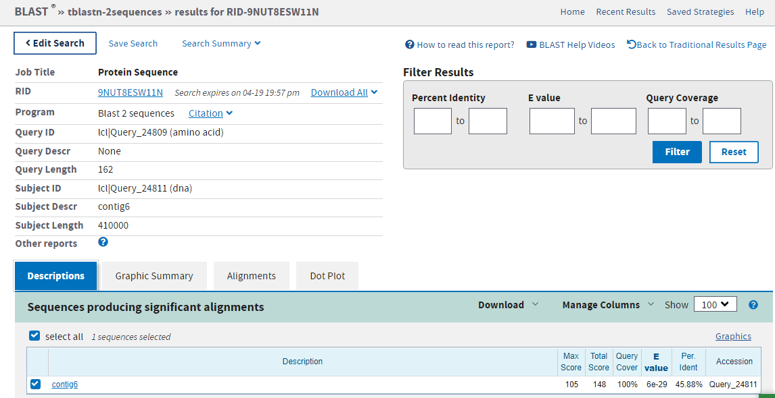
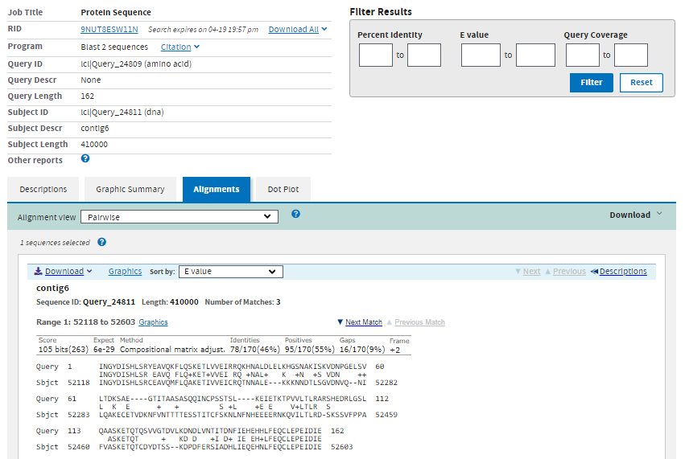
Exon 3 polypeptide
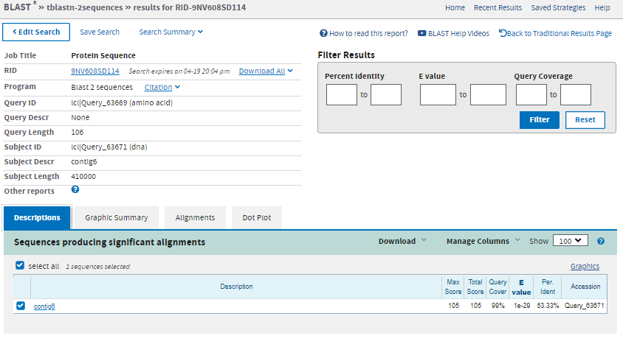
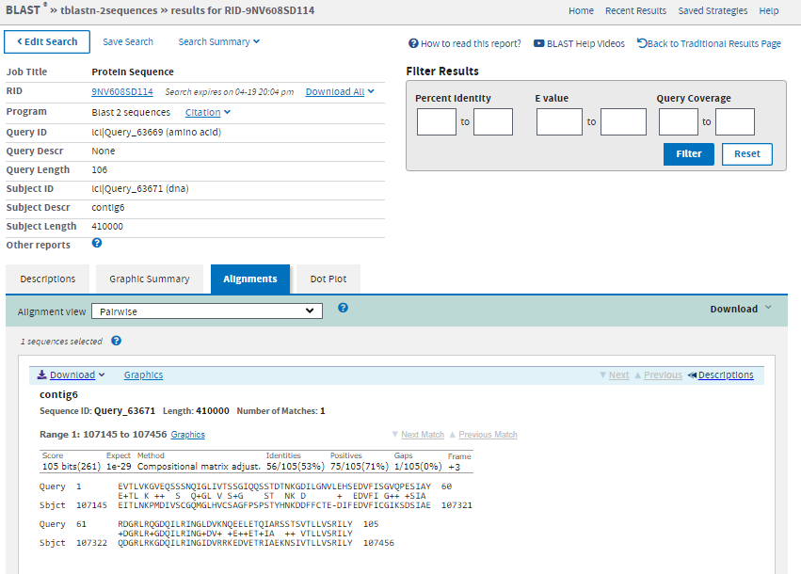
Exon 4 polypeptide
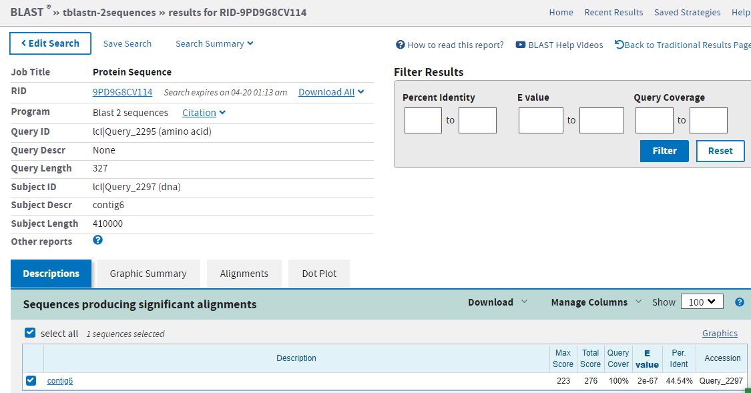

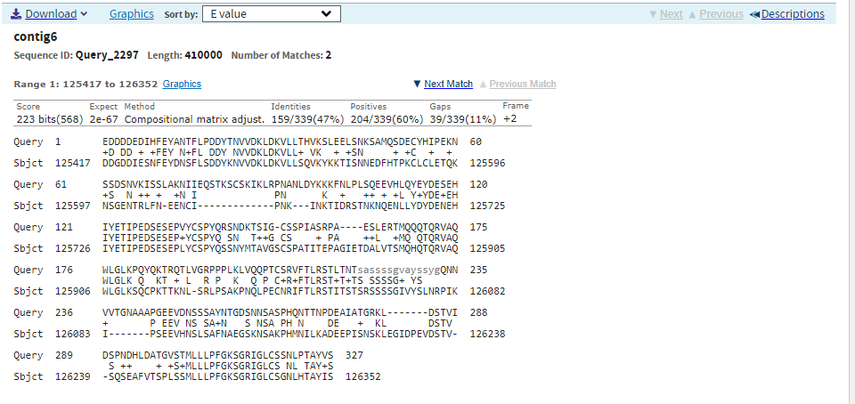

Exon 5 polypeptide
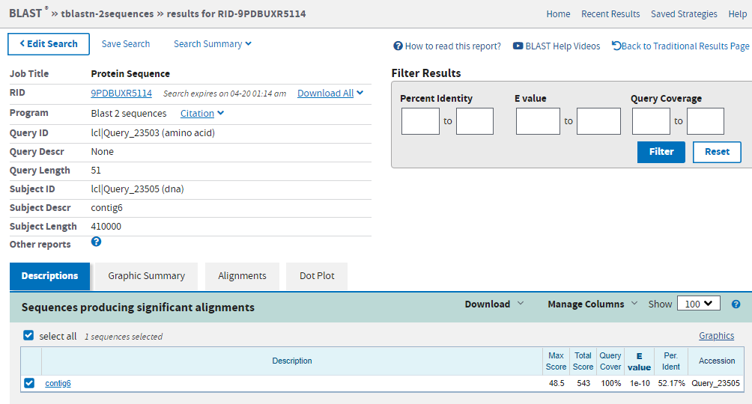
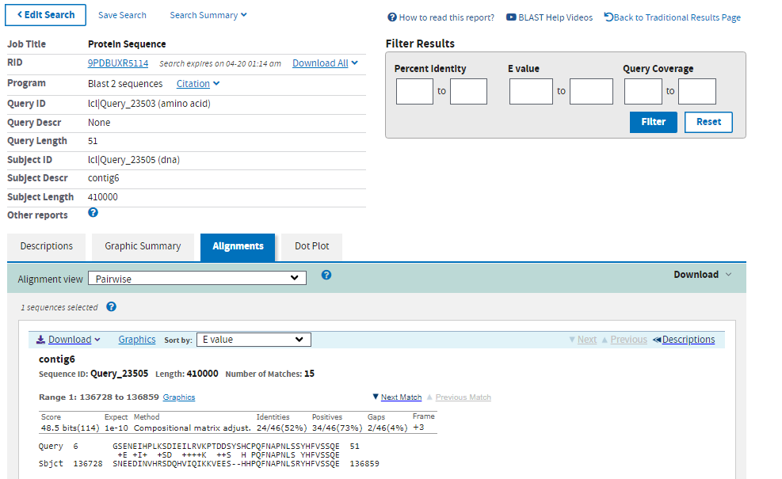
Exon 6 polypeptide
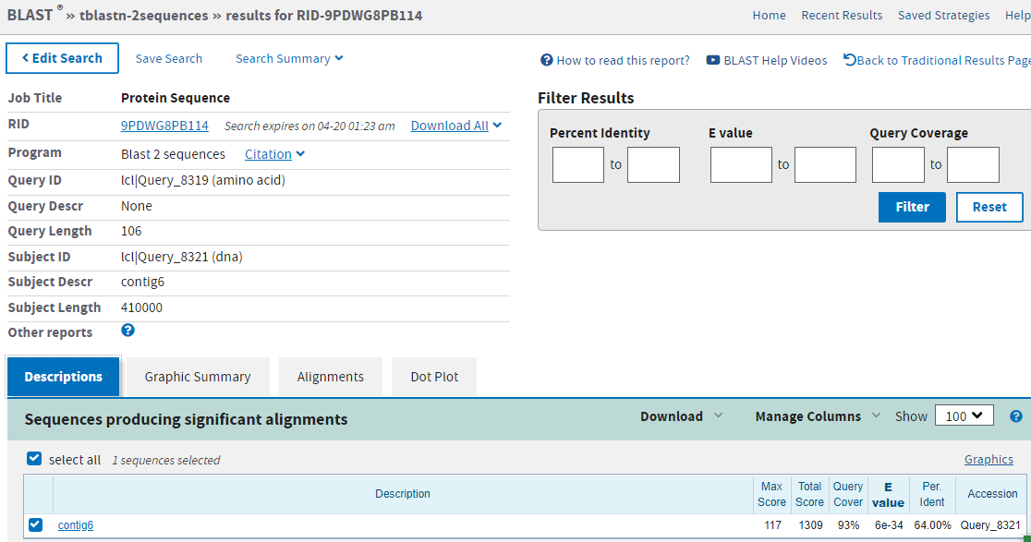
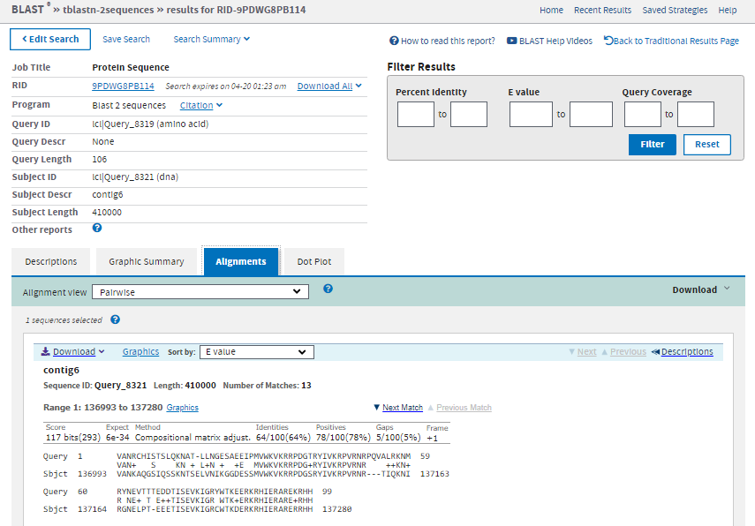Transcript SLIP1-PB - has 5 Exons
Query is polypeptide sequence from exons ; Subject is Contig6 sequence.
Exon 1 Polypeptide
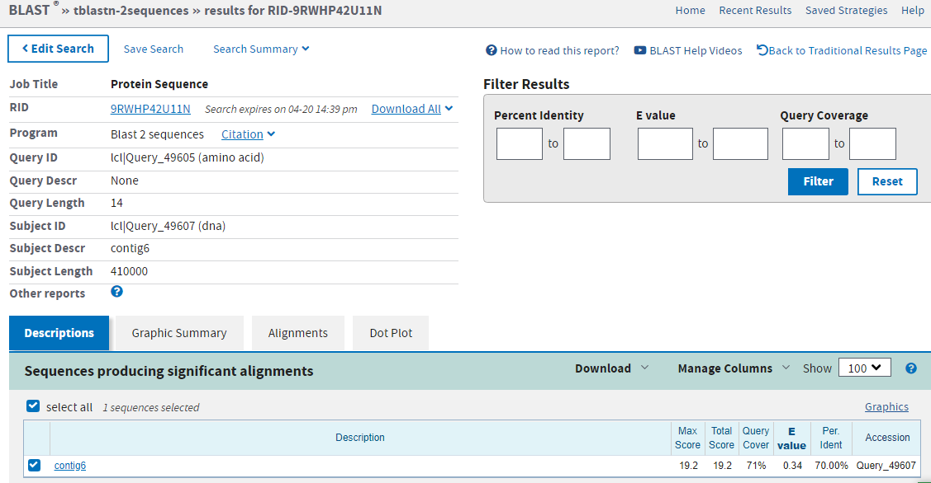
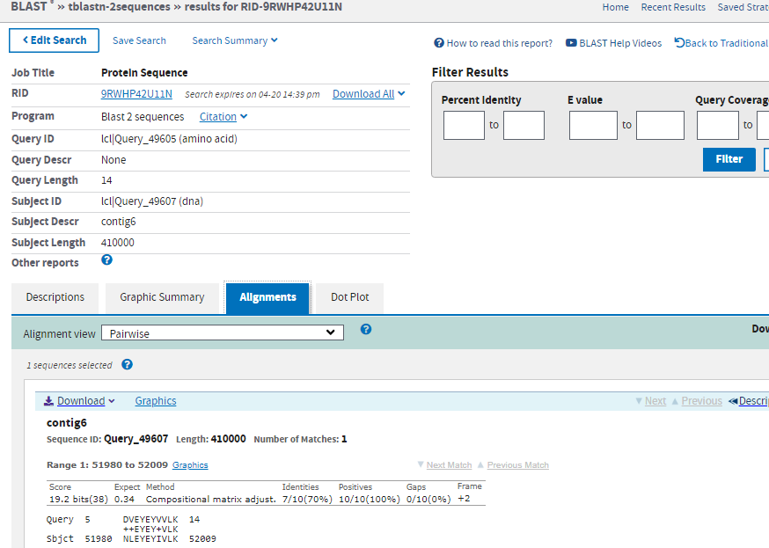
Exon2 Polypeptide
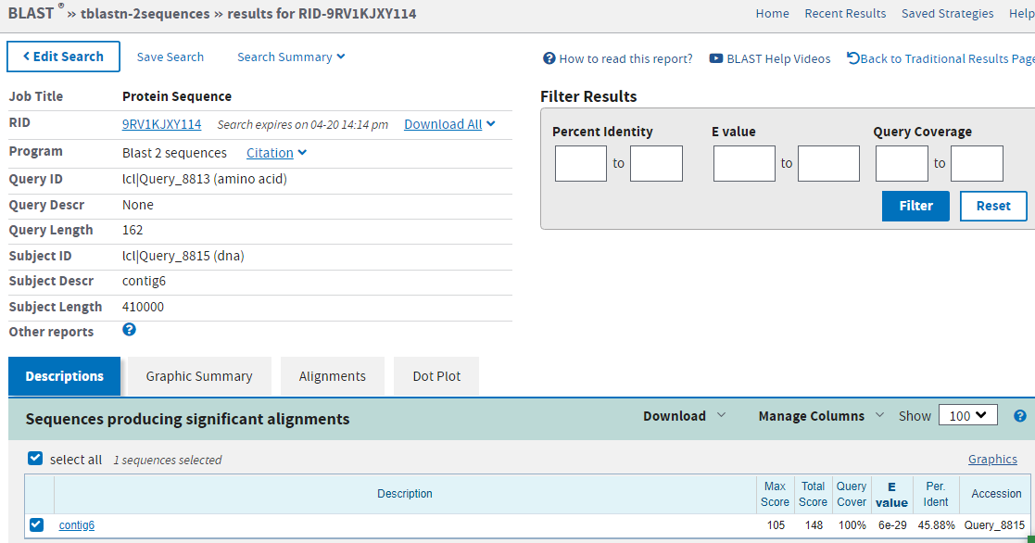
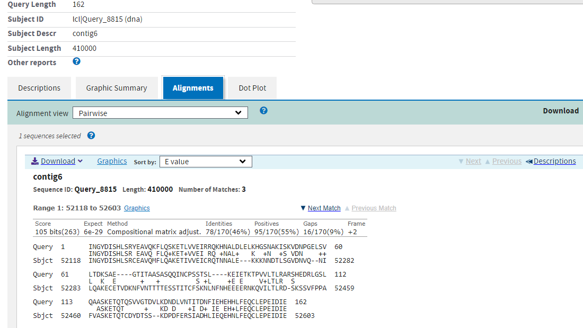
Exon 4 Polypeptide
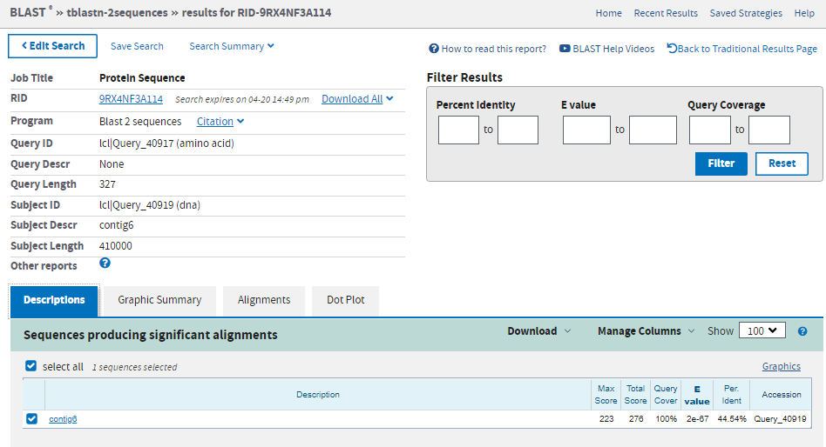
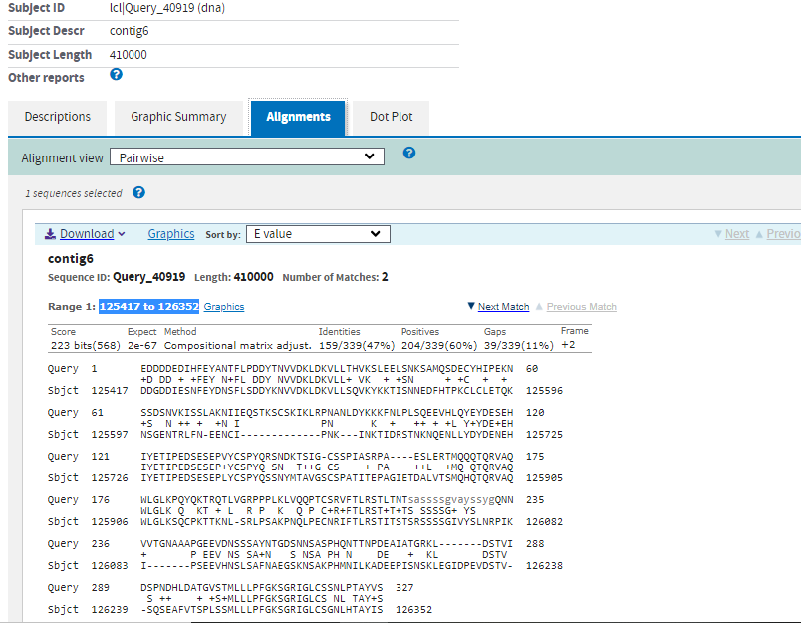

exon 5 polypeptide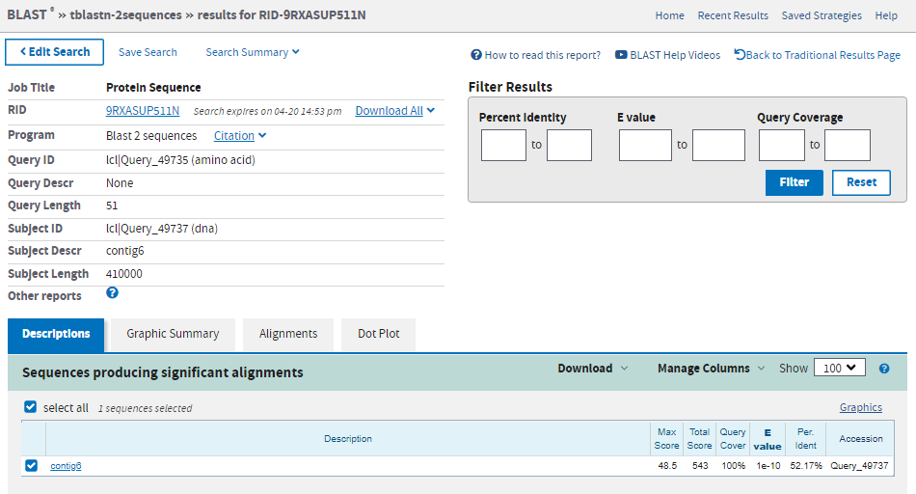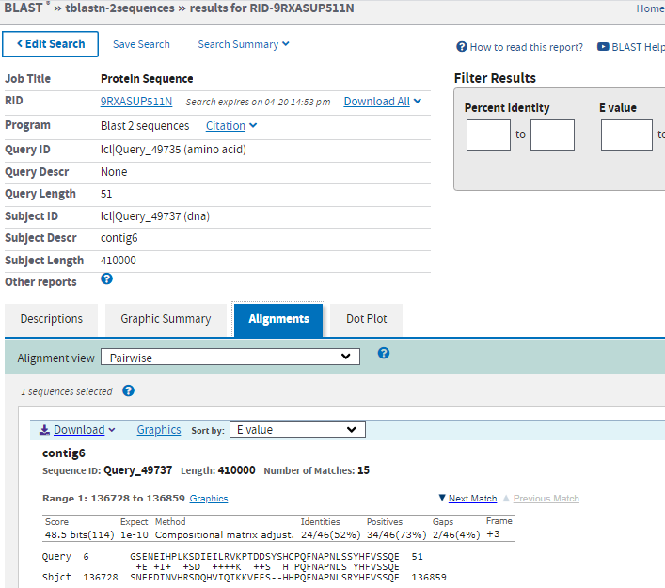
Exon 6 polypeptide
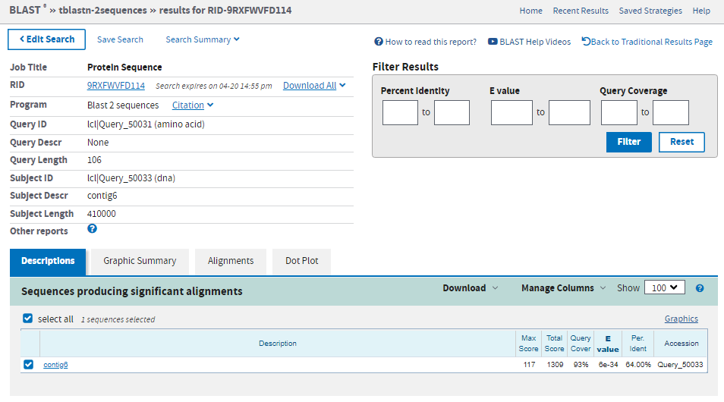
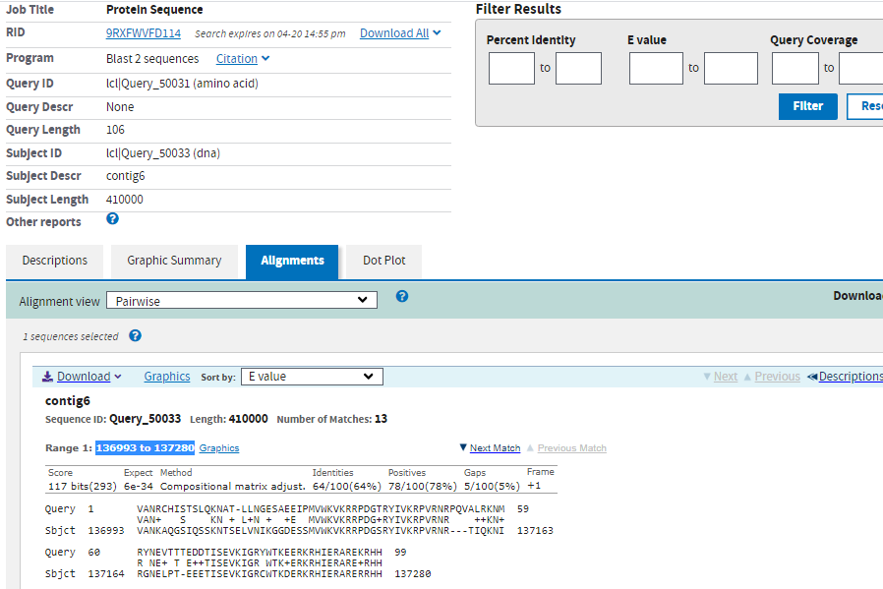

Transcript SLIP1-PC - has 5 Exons
Exon 1 Polypeptide
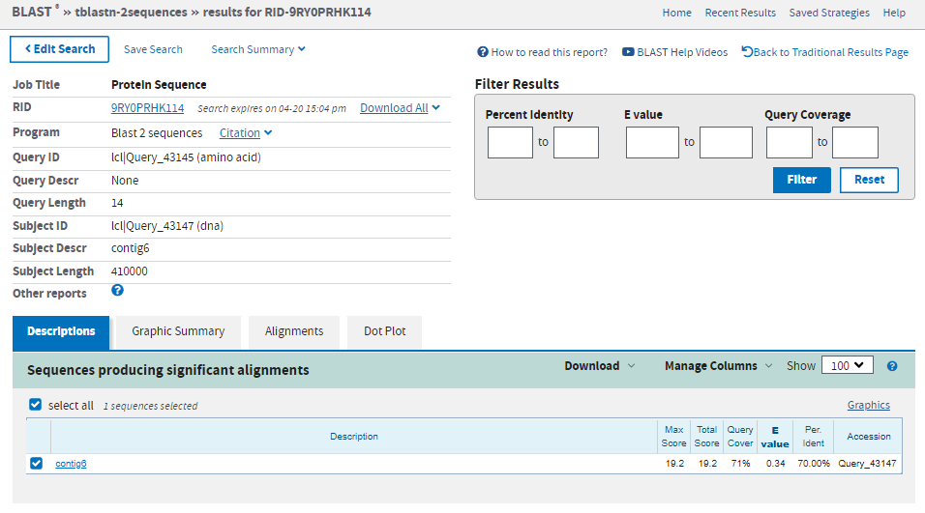
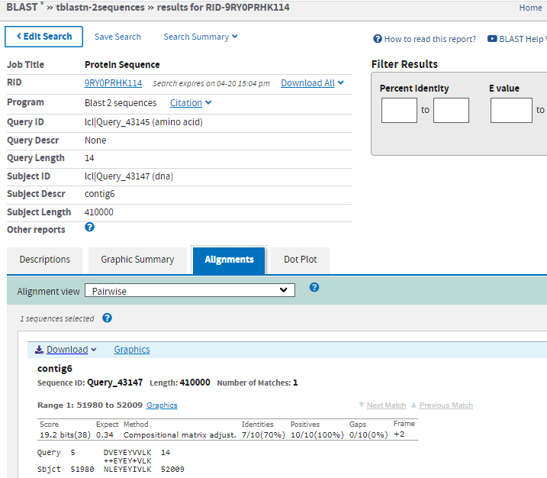
exon 2 polypeptide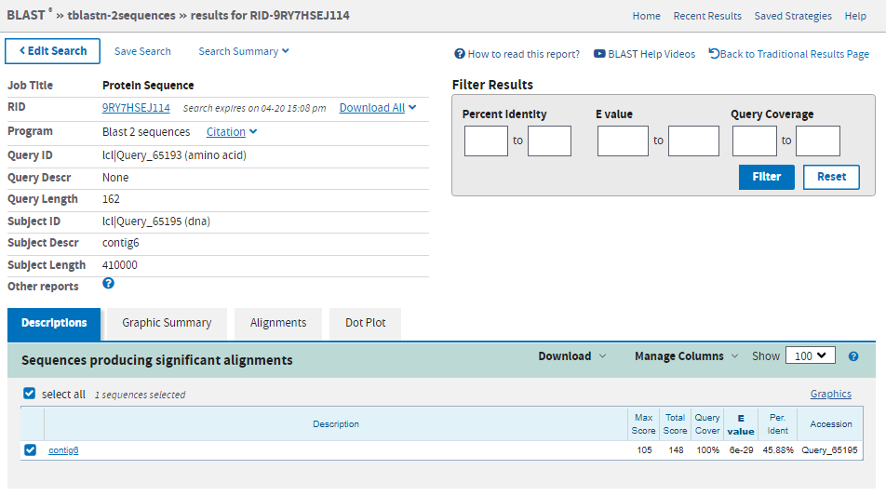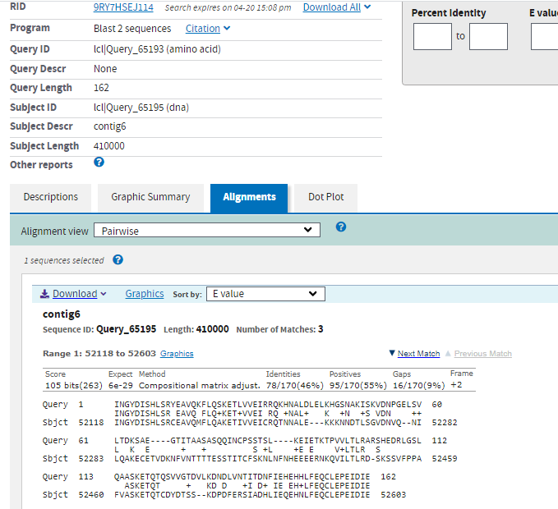
Exon 3 polypeptide
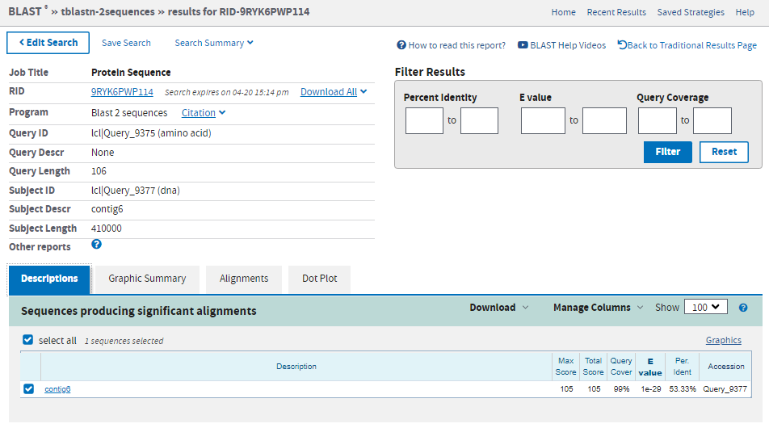
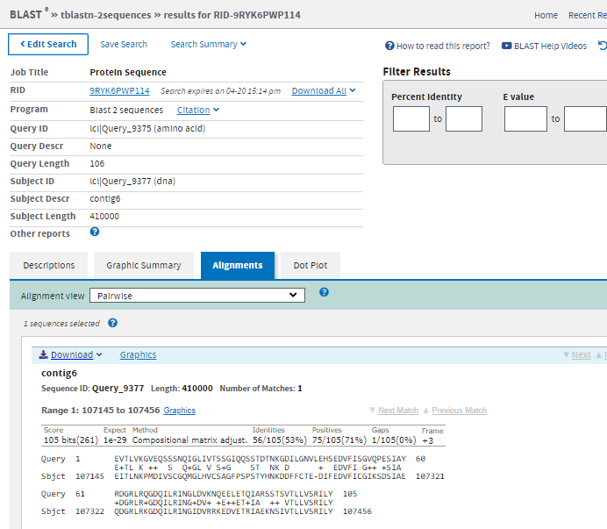
Exon 4 polypeptide
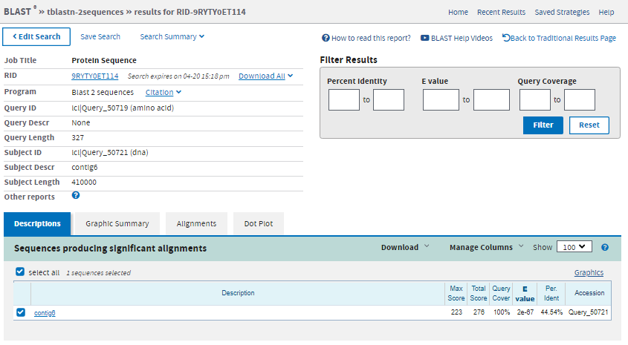
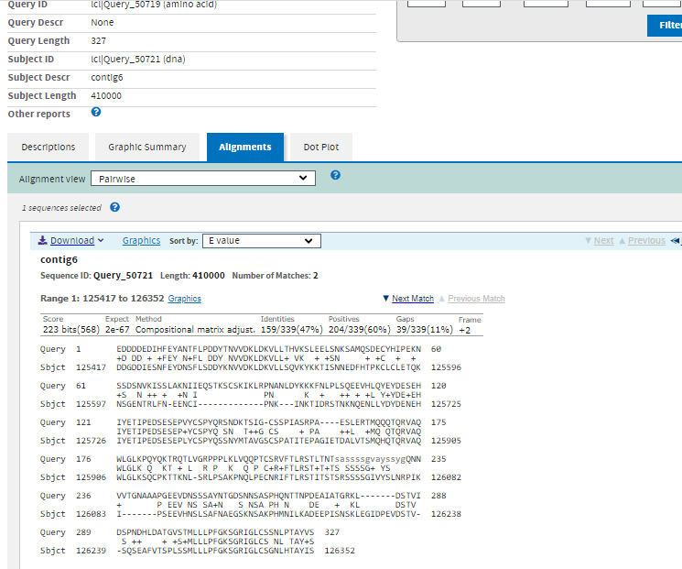

Exon6 polypeptide
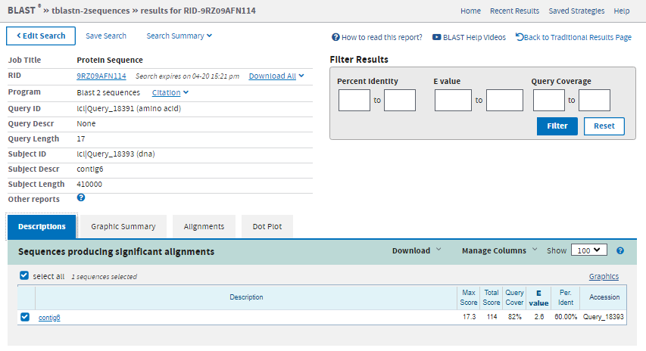
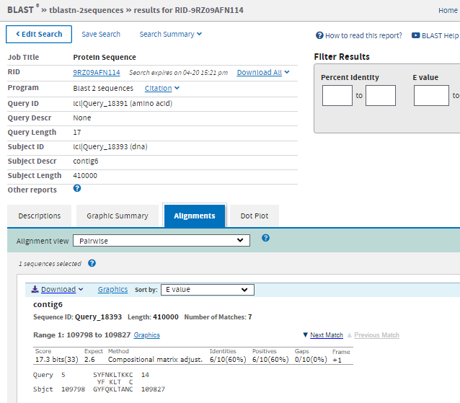
- Fill in the table using the information from BLAST (If you have more exons feel free to add extra boxes. If you have less than 10 exons feel free to remove boxes)

Coding Exon | Polypeptide length (a.a) | Exon Length  In CDS | Full length blast alignment | Reading frame from BLAST | Crude Map Coordinates in contig | E value
Slip 1 - transcript PA
1 | 14 | 42 | In answer 3 | +2 | 51980 to 52009 | 0.34
2 | 162 | 486 | In answer 3 | +2 | 52118 to 52603 | 6e-29
3 | 106 | 318 | In answer 3 | +3 | 107145 to 107456 | 1e-29
4 | 327 | 982 | In answer 3 | +2 | 125417 to 126352 | 2e-67
5 | 51 | 155 | In answer 3 | +3 | 136728 to 136859 | 1e-10
6 | 106+stop codon | 321 | In answer 3 | +1 | 136993 to 137280 | 6e-34

Coding Exon | Polypeptide length (a.a) | Exon Length ( in bp) in CDS | Full length blast alignment | Reading frame from BLAST | Crude Map Coordinates in contig | E value
Slip 1 - transcript PB
1 | 14 | 42 | In answer 3 | +2 | 51980 to 52009 | 0.34
2 | 162 | 486 | In answer 3 | +2 | 52118 to 52603 | 6e-29
4 | 327 | 982 | In answer 3 | +2 | 125417 to 126352 | 2e-67
5 | 51 | 155 | In answer 3 | +3 | 136728 to 136859 | 1e-10
6 | 106+ stop codon | 321 | In answer 3 | +1 | 136993 to 137280 | 6e-34
Slip 1 - transcript PC
1 | 14 | 42 | In answer 3 | +2 | 51980 to 52009 | 0.34
2 | 162 | 486 | In answer 3 | +2 | 52118 to 52603 | 6e-29
3 | 106 | 318 | In answer 3 | +3 | 107145 to 107456 | 1e-29
4 | 327 | 982 | In answer 3 | +2 | 125417 to 126352 | 2e-67
6 | 17+ stop codon | 54 | In answer 3 | +1 | 109798 to 109827 | 2.6

5. How many putative exons do you have? Do you think that your gene in the assigned contig an exact ortholog of the D.melanogaster gene?

